Technology Integration Rubric
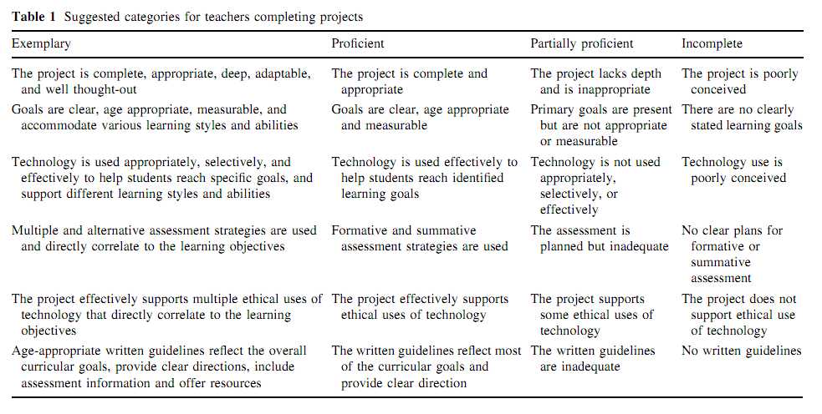
Reference
Keengwe, J., & Onchwari, G. (2009). Technology and Early Childhood Education: A Technology Integration Professional Development Model for Practicing Teachers. Early Childhood Education Journal, 37(3), 209-218. doi:10.1007/s10643-009-0341-0

